6.33: 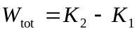
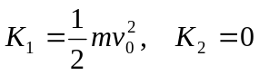
Work is done by the spring force. 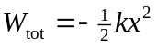, where x is the amount the spring is compressed.
